Thames Water Utilities Ltd
Clearwater Court,
Vastern Road,
Reading,
RG1 8DB

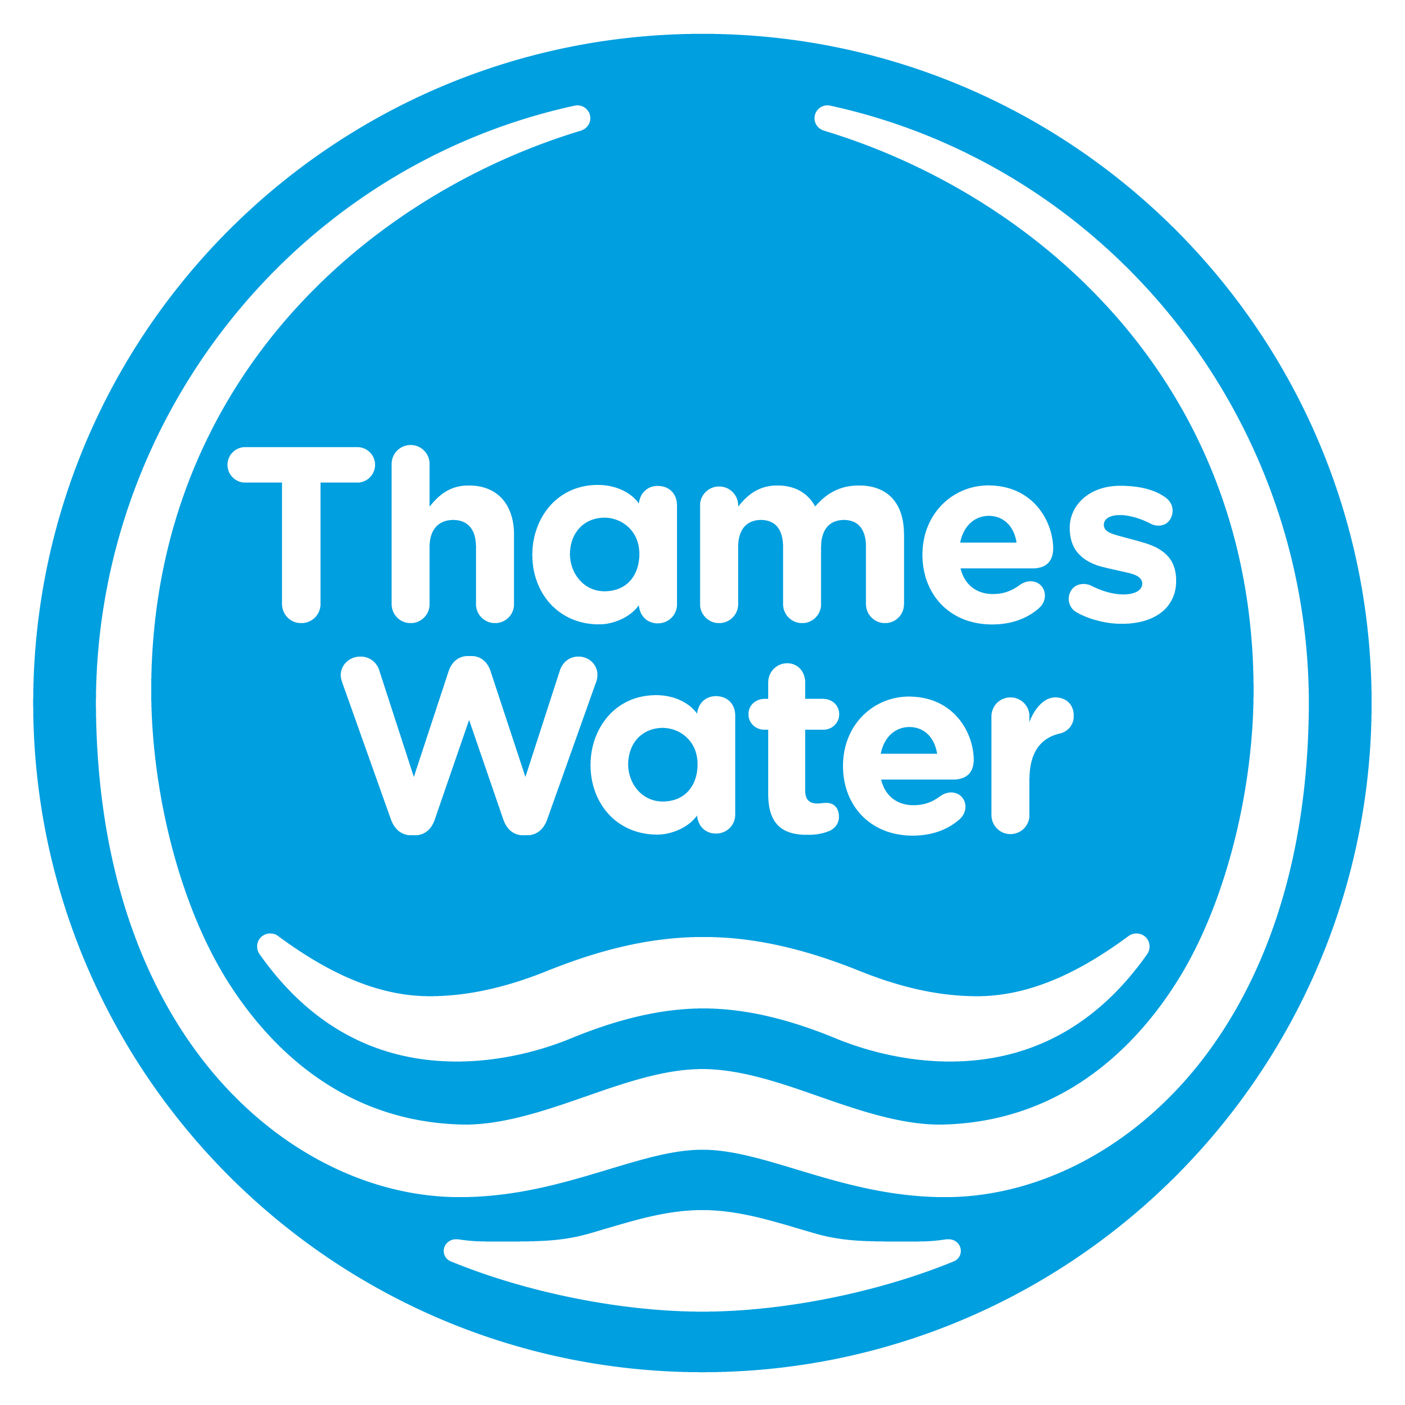

[Date]

Dear Sir/Madam
Authorisation to collect, use and release of consumption data and/or digital meter data
We, [Customer Name e.g. ‘XYZ Ltd’], have engaged [Company name] for the premises stated below.
Premises address | Meter details

We have requested that [Company name] collect consumption data and/or digital meter data at the premises on our behalf. In order to undertake this service, we authorise Thames Water Utilities Limited (“Thames Water”), in relation to the premises, to collect, use and release the consumption data and/or digital meter data to [Company name] as indicated below (tick all that apply):
Historic consumption data
From start date ………………….…………to end date ………………….…………
Ongoing consumption and/or digital meter data on the following frequencies:
Monthly
Hourly
15 minute intervals
From start date ………………….………… for a period of two years or until we notify Thames Water in writing that the above consent is withdrawn (if earlier).

We acknowledge that:
- Thames Water makes no warranty or guarantee as to the availability, accuracy or suitability for any consumption data and/or digital meter data for any purpose,
- Thames Water shall not be liable for any loss, costs, expenses and damages whatsoever suffered or incurred arising out of or in connection with the release of or use of the consumption data and/or digital meter data, howsoever arising,
- the retailer is a data processor acting on my instruction and therefore any abuse of that data will be my potential action against the retailer as data processer,
- where Thames Water has a legitimate interest to collect/hold data on a particular frequency, the giving or removing of consent under this letter shall not affect the rights of Thames Water to collect/ hold the data.

We hereby acknowledge and declare that:
- the information provided in this form is correct to the best of my knowledge and up to date at the time of submission
- I have read and agree to the Thames Water privacy notice/statement on the Thames Water website
Yours faithfully
Authorised signature …………………………………………………………………………………
Full name………………………………………………………………………………………………
Date…………………………………………………………………………………………………….

Consumption data: means data which represents the quantity of water that has flowed through the Meter and therefore gives an indication of the volume of water consumed. The data is in l/s (litres per second) and is usually provided in 15 minute intervals. However, the frequency of the intervals may vary. The data is captured by Consumption Monitoring Equipment installed on the Meter.
Please note where the equipment on your premises is a data logger, these loggers are restricted to capture data in 15 minute intervals and so the frequency will default to 15 minutes regardless of your indication of frequency.
Digital data: means electronic capture of the meter reading as shown by the meter at various intervals including monthly, hourly and 15 minute.

